Methods
Study design
This study was designed as a retrospective observational study carried out at the medical faculty of Ulm in Baden-Württemberg/Germany between July 2022 and July 2023.
Medical students at Ulm university are enrolled in a lecture and a consecutive seminar on clinical pharmacology, which extend over one semester each and both conclude with a written exam. As part of the regular curriculum, Students are assigned to either of two groups and will be enrolled in the lecture either in the seventh or in the eight semester, and in the seminar in the subsequent semester.
Examinees of three seminar exams (seminar 2022, seminar 2022/23, and seminar 2023), and examinees of two lecture exams (lecture 2022, lecture 2022/23), in total 820, were invited to participate in the study. The number of individual students is lower, since many examinees of the lecture exams for 2022 and 2022/23 did later participate in the seminar exams of 2022/23 and 2023 respectively.
The exams are single best answer tests consisting of 40 (lecture) or 30 (seminar) test items each with five options per item. Each correct item yields one point. Passing both exams as well as attending the seminar are mandatory part of the curriculum, while lecture attendance is optional.
At the beginning of the lecture and of the seminar, students were made aware of the option to use Anki flash cards for studying, which were available for download on the course material website. Also available were a brief manual (detailing installation of the most up-to-date Anki version and importing, creating, and editing cards), as well as an FAQ.
Anki cards creation and structure
Anki is an open-source flashcard software available for most desktop and mobile platforms. Anki allows users to study material following a spaced repetition algorithm, in which the interval until next review of a card is determined by the learner’s self-rated confidence of correct recall. Cards in which recall is rated as difficult are scheduled for earlier repetition, and cards which were more easily remembered reoccur after a longer interval. Content for Anki can be downloaded from a free and user-generated online repository or created by end-users themselves.
Anki cards for 226 drugs had been created by institute staff and were based on the 2021 version of the IMPP Arzneistoffliste (IMPP, 2021). The Arzneistoffliste defines key drugs and serves as an official guideline for the pharmacology-related items of the centralized written German medical licensing examinations.
Cards were organized in distinct decks according to medical fields, and further divided into two decks for each field:
- A basis deck showing the drug name on the front, and on the back either the effect, the mechanism of action, indications, contraindications, or side effects
- A comprehensive knowledge deck, showing the drug name on the front and extended drug information on the back.
Information on the back was mostly presented as bullet lists or single terms, and occasionally short texts or diagrams when appropriate. Cards were tagged for efficient filtering in Anki, including a tag for those cards considered relevant for the exam concluding the lecture and the seminar.
Other studying materials made available to students were lecture and seminar slides, comprehensive electronic scripts accompanying the lecture, example questions, case tasks and exercises as part of our e-learning repository, and textbook recommendations. Students were free to download external Anki decks or create their own.
Questionnaire
Immediately after both the lecture and seminar exam, students were handed survey questionnaires. The questionnaires comprised 11 items for the seminar 2022 cohort, while the other four cohorts (lecture cohort 2022/23, seminar cohort 2022/23, lecture cohort 2023, and seminar cohort 2023) were given an extended questionnaire of 22 items for providing comprehensive insights into their Anki-usage. Some results therefore do not include answers from the seminar 2022 cohort.
Students were asked which learning strategies they employed and considered particularly useful for exam preparation, including institute-supplied Anki cards. Students were also asked whether they had used Anki cards in general as a filter question, and were asked to report on their Anki usage in detail when answering positively. These detailed questions included whether students considered Anki cards useful in general, to what extent they used them, for what purposes and in which situations, and on what kind of device. If students denied having institute-supplied cards in general, they were asked to select a reason. Participants were further asked to rate their academic performance in general, and in clinical pharmacology in particular, on a five-point ordinal scale. Since exam scores in other subjects were not available to us, self-assessment of academic performance served as a proxy. Students were finally asked for basic demographic information.
Students explicitly consented to data processing.
Students generate a pseudonymous code as part of routine exam procedure to write on their response sheet before handing it in. For this study, they were invited to voluntarily provide their code on the survey questionnaire as well, allowing us to pseudonymously associate survey questionnaires with exam results.
Statistics
For descriptive statistics, exam scores were transformed into percentages of maximum scores. For inference statistics, exam scores were z-standardized within each cohort before pooling to account for differing exam difficulty.
Differences in categorical variables were assessed using chi-square tests, and ordinal variables were compared between groups using Wilcoxon rank-sum tests.
To investigate whether exam performance differed between Anki users and non-users, we first fitted an unadjusted linear regression model with exam score as the dependent variable and Anki use as the independent variable. We then fitted an adjusted model including self-rated academic performance as a covariate to account for potential confounding by general academic ability. Since not all students gave a self-assessment of their performance, the unadjusted linear regression was repeated with a dataset restricted to students who provided self-assessment.
For all regression analyses, students with missing data on relevant variables were excluded from the respective models. Statistical significance was set at p < 0.05.
All other inference statistics were done using correlations reporting Spearman's ρ.
Statistical analysis was performed in R version 4.4.1 (R Core Team, 2024), using the package ggplot2 (Wickham, 2016) for figures.
Offene Fragen Methodenteil:
- Alle Beobachtungen wurden als unabhängig gewertet, auch wenn die Stud. evtl. in einer späteren Kohorte auftauchen. Soll ich das beschreiben und begründen? Oder soll ich die Statistik wiederholen und die Beobachtungen als zum Teil abhängig betrachten? Dann müsste ich mich schlau machen, wie das geht, weil das ja die erste Kohorte gar nicht betrifft, und in den übrigen Kohorten nicht alle Stud.
- In einigen ähnlichen Papers wird erwähnt, dass kein Ethics approval notwendig war. Soll ich auch so etwas schreiben?

Results
Out of 920 participants in the exams, 820 (89.91%) returned the survey questionnaire, consented to data processing, and filled in their pseudonymous code to pair survey data with exam scores (Table 1). Over all exams, participants correctly answered 75.3% of items, with significantly higher score percentages in lecture exams (77.4%) as compared to seminar exams (73.8%), t(678) = 3.90, p < .001, 95% CI [1.76, 5.33. Among participants who declared a binary gender, the proportion of women was 62.1%, which is close to the German average of female medical students for 2022 at 64.4% (Statistisches Bundesamt, 2025).
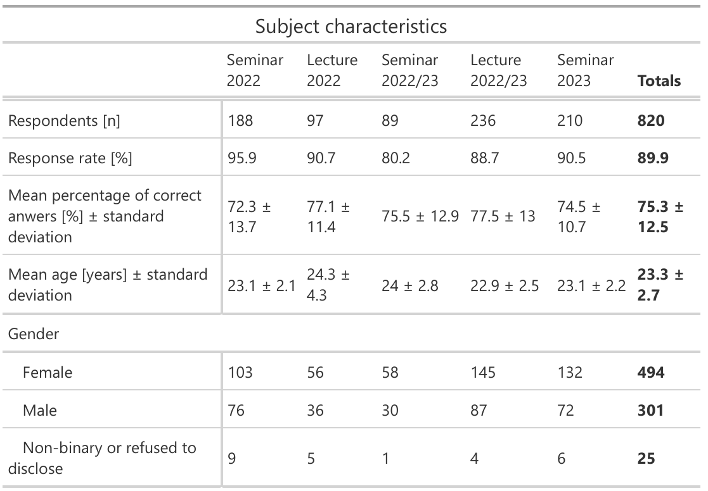
Table 1. Demographic and response characteristics of the study population.
- Table 1: High response rate, higher percentage of female students
The most used method for exam preparation were digital scripts (Figure 1), followed by physical scripts and institute-supplied Anki cards. Anki card usage differed significantly between preparation for lecture exams (45.0%) vs. seminar exams (18.1%), χ²(1, N = 818) = 2.636, p < .001.
Students considered scripts (both digital as well as physical) most useful for exam preparation, followed by videos of lectures and seminars (Figure 2). Among students who declared having used Anki for exam preparation (33.2%), 65.4% counted Anki cards among those studying materials considered “particularly helpful” in exam preparation (Figure 3), with no significant differences between cohorts, χ²(3, N = 214) = 2.636, p = 0.4512. Among those students who reported having used institute-provided Anki-cards in general (32.4%), 81.9% considered Anki cards as helpful in general (Figure 4), with no significant differences between cohorts either, χ²(6, N =232) = 7.1529, p = 0.3069.
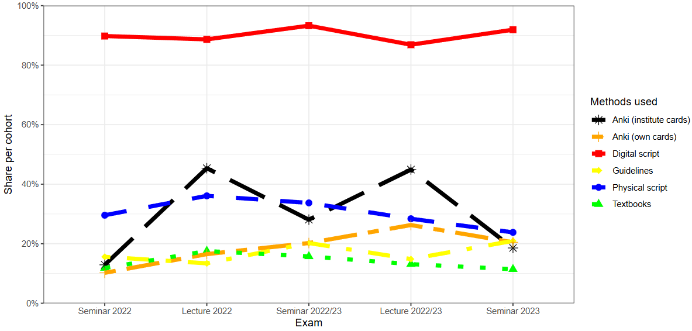
Figure 1. Methods used for exam preparation by cohort. Multiple answers allowed.
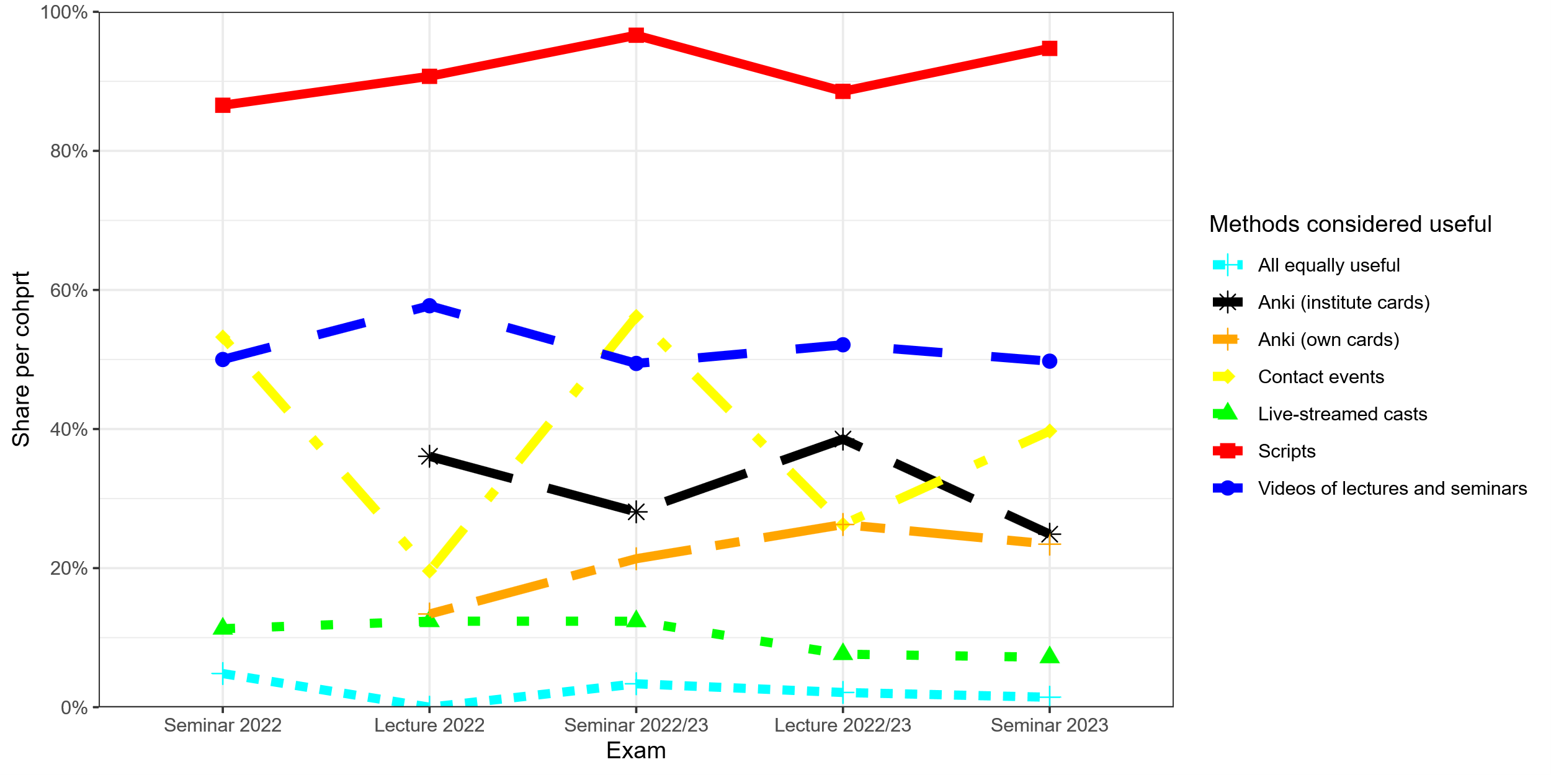
Figure 2. Methods considered particularly helpful for exam preparation among all students by cohort. Multiple answers allowed.
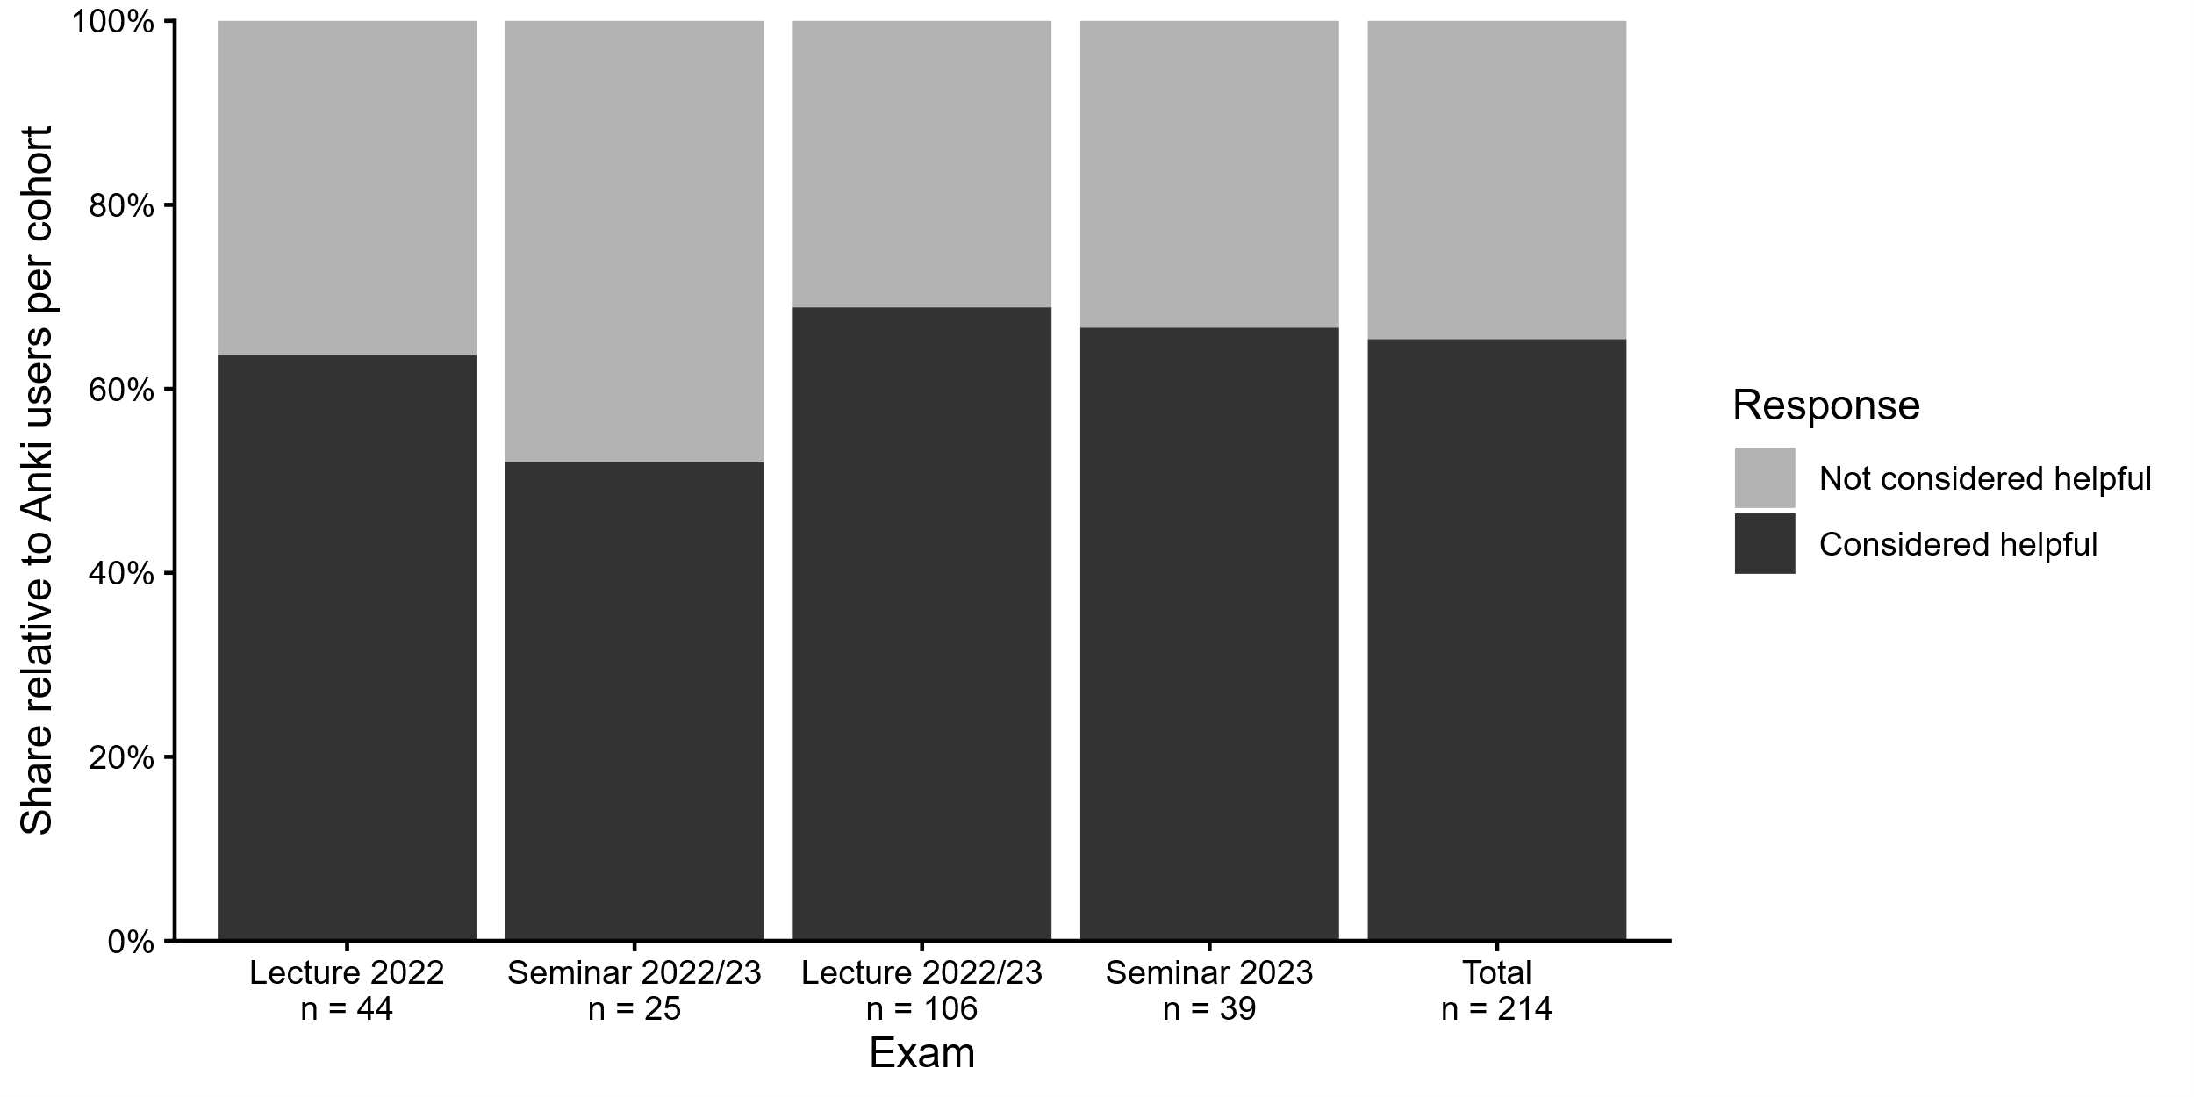
Figure 3. Share of students who considered Anki as “particularly helpful” in exam preparation, relative to all students who prepared for the exam using Anki institute cards.
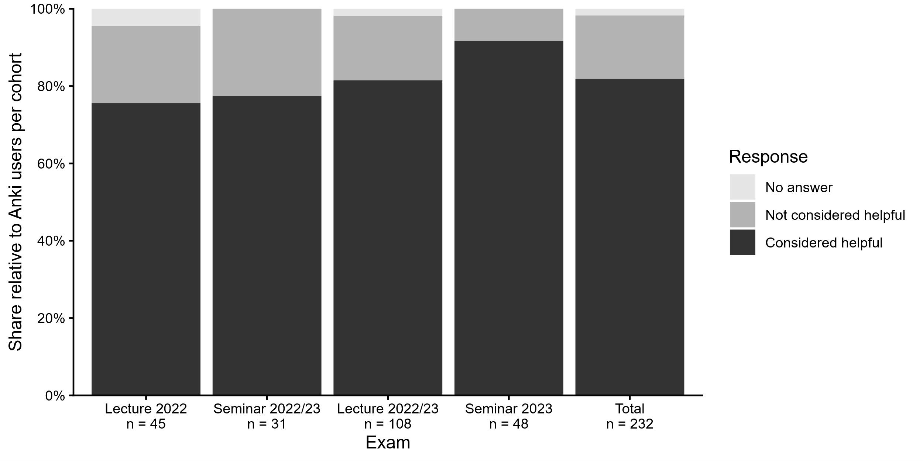
Figure 4. Share of students who considered Anki institute cards as generally helpful, relative to all students who declared having used the cards in general.
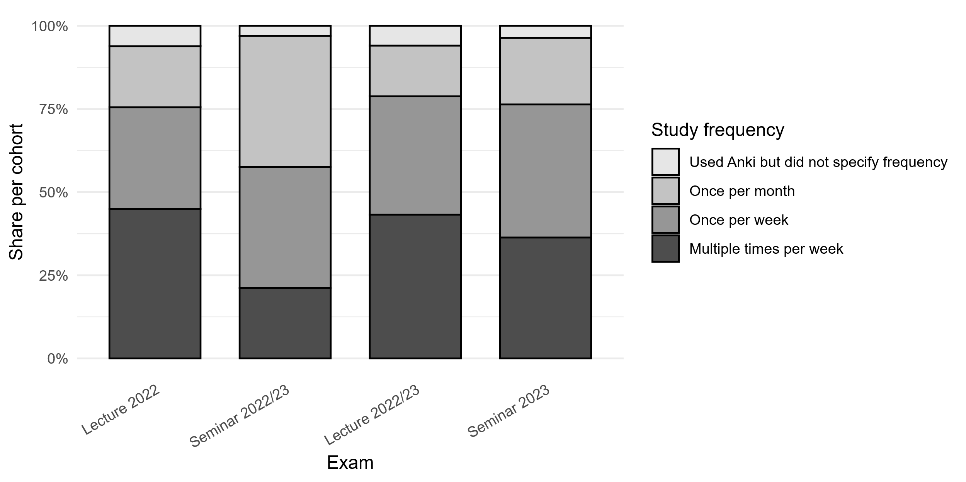
Figure 5. Frequency of Anki usage among students who reported having used Anki cards in general.
Among those students who reported having used Anki cards in general
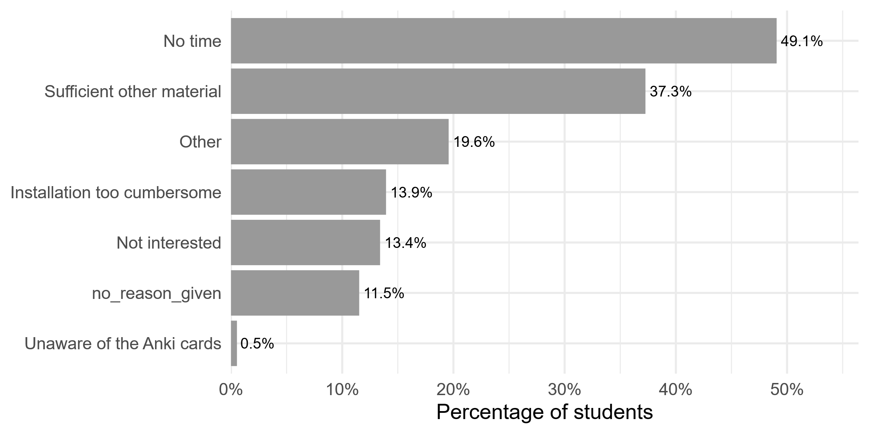
Figure 6. Reasons for not using Anki.
- Main reason for not using Anki: no time, and sufficient other material. Particularly digital scripts were probably considered sufficient by most students, judging from their popularity.

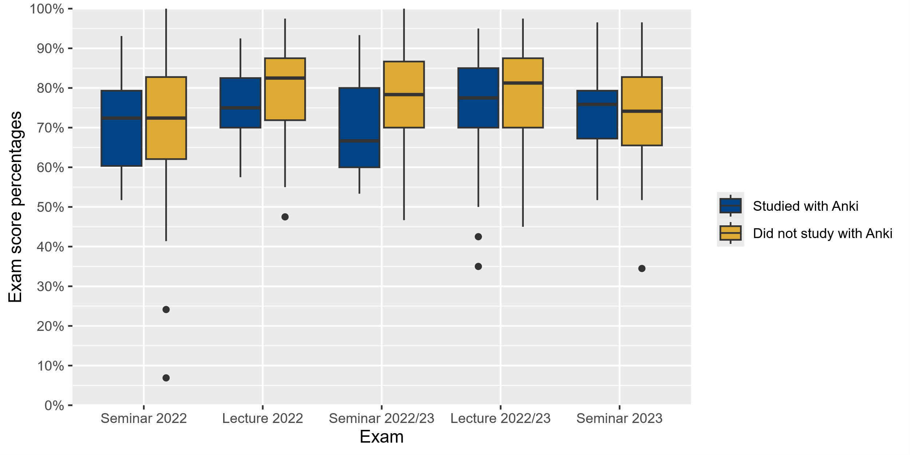
Figure 7. Anki usage and exam scores by cohort.

- Students not studying with Anki have similar or higher scores than those studying with Anki. Both in Seminar as well as lecture, there does not seem to be an effect related to whether cards were used for lecture or seminar.
- Anki usage is significantly and negatively related to z-standardized exam scores:
Anki learners perform by about 0.19 standard deviations worse compared to non-Anki learners, significant with a p-value of 0.01776

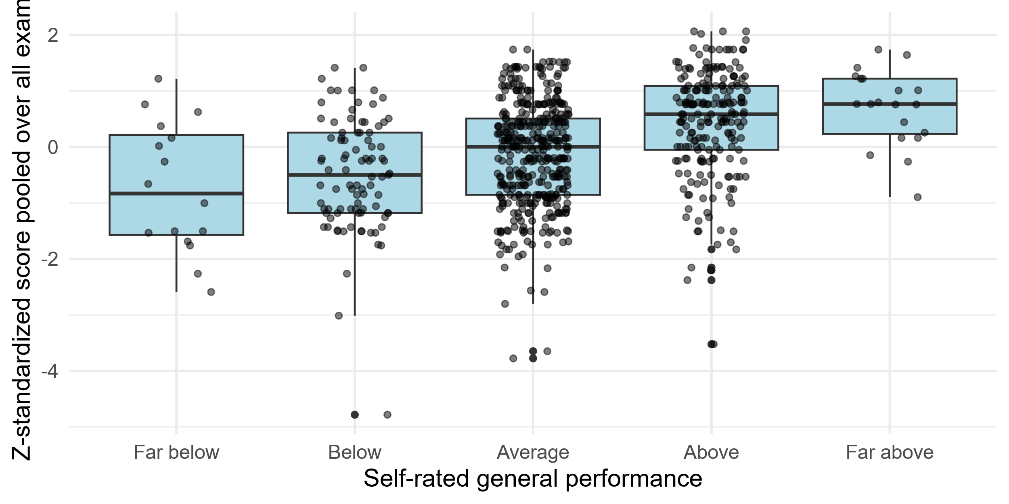
Figure 7. Relationship between self-rated academic performance and standardized exam scores.
- Self-rated general academic performance (“Wie schätzen Sie Ihre Studienleistung insgesamt im Vergleich zu anderen Studierenden Ihres Semesters ein?“) correlates well with pharmacology exam score.
- Correlation is highly significant: p-value < 2.2e-16, rho 0.3458337

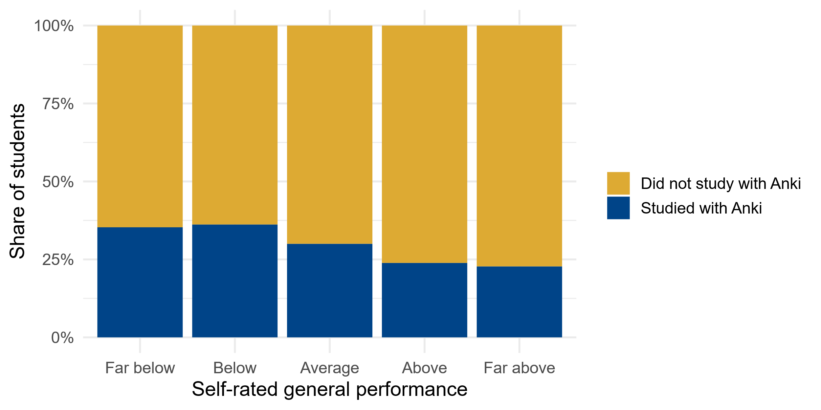
Figure 8. Self-rated performance and Anki usage.
- Students with self-rated better general academic performance tend to not use Anki!
- Self-rated general performance has a significant and negative correlation with Anki usage:
p-value = 0.01395; rho -0.08755729
- Since students who studied with Anki performed significantly lower in the exam, and students with self-rated lower general academic performance tended to use Anki, we wondered whether the relationship between Anki use and exam score was confounded by academic performance. In the unadjusted linear regression model, Anki users scored significantly lower than non-users (β = –0.19, SE = 0.08, p = 0.018). However, after adjusting for self-rated general academic performance, this association was no longer statistically significant (β = –0.13, SE = 0.08, p = 0.095). Self-rated academic performance was strongly associated with exam results (β = 0.43, SE = 0.05, p < 0.001). The adjusted model explained 11% of the variance in exam scores, compared to less than 1% in the unadjusted model.
An F-test comparing the adjusted with the unadjusted model confirmed that including self-rated performance significantly improved model fit (ΔR² = 0.126; F(1, 746) = 89.35, p < 0.001). The adjusted model explained 11.3% of the variance in exam scores, compared to less than 1% in the unadjusted model.
Fehlt noch im Results-Teil:
- Signifikanter Unterschied zwischen Kategorien (z.B. lernten sign. mehr Stud. mit den Karten für die Vorlesungsklausur als für die Seminarklausur?). Aber ist das überhaupt nötig zu untersuchen?
- Zeitaufwand der Kartenerstellung
- Die Nutzung keines der anderen Lernmittel (eigene Ankikarten, digitale und physische Skripte, Leitlinien, Lehrbücher) war signifikanter Prädiktor des Examscores. Sollte ich das trotzdem erwähnen, dass der Zusammenhang untersucht wurde, aber nichts gefunden wurde? Interessanterweise waren die meisten Lernmittel negativ mit dem Score korreliert, aber eben wie gesagt nicht signifikat.
Conclusions
- Anki cards were mainly used for studying for lecture, not seminar exam, perhaps since seminar exams are known to have a stronger focus on case miniatures
- Students performed significantly worse when studying with Anki, but this effect was not significant anymore when controlling for general academic performance. Students with lower academic performance seem to have opted for Anki as studying aid, perhaps hoping to compensate with Anki cards for a comparatively lower academic ability as compared to students with high self-rated performance.
- No causality can be inferred since no randomization was done, observational study only. However, in reality students self-select their studying material as well, and a randomized study would have missed self-selection of lower-performing students for Anki.
References
Statistisches Bundesamt (Destatis). (2025). Studierende insgesamt und Studierende Deutsche im Studienfach Medizin (Allgemein-Medizin) nach Geschlecht [Data set]. GENESIS-Online. https://www-genesis.destatis.de

